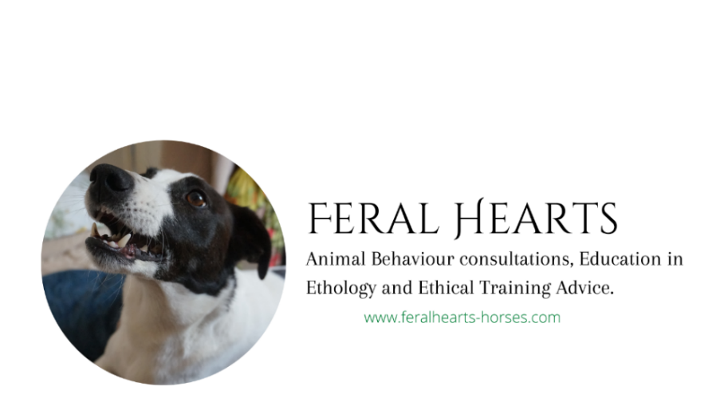
Jenny Barker
33, Hobsic Close, Brinsley
Nottinghamshire, NG16 5AX
07505000709
www.feralhearts-horses.com
feralhearts_behaviour@yahoo.com

Veterinary Referral Form: Equine and canine behaviour consultations

Referring Veterinary Surgeon: ________________________________________________
Practice Name: ____________________________________________________________
Practice Address:___________________________________________________________
_________________________________________________________________________
Practice Telephone Number: ______________________ Email: ________________________________
Brief details of behaviour problem: Date first evident: ___ / ___ / ___
___________________________________________________________________________________________________________________________________________________________________________________________________________________________
Clinical history: detailed below to follow appended
__________________________________________________________________________________
__________________________________________________________________________________
__________________________________________________________________________________

Client Details
Name: _____________________________________________________________________
Address: ___________________________________________________________________
___________________________________________________________________________
Telephone number(s): _________________________________________________________
Patient name: _____________________ Species / Breed: ____________________________
Patient age: __________ Sex: male female Casterated: yes no

I acknowledge my approval for the above client and patient to be referred to Jenny Barker. I understand a copy of the full report, detailing the assessment and treatment plan, will be accessible to me by request via email/post after the consultation.

Signed (Veterinary Surgeon): ____________________________ Date: ________________

